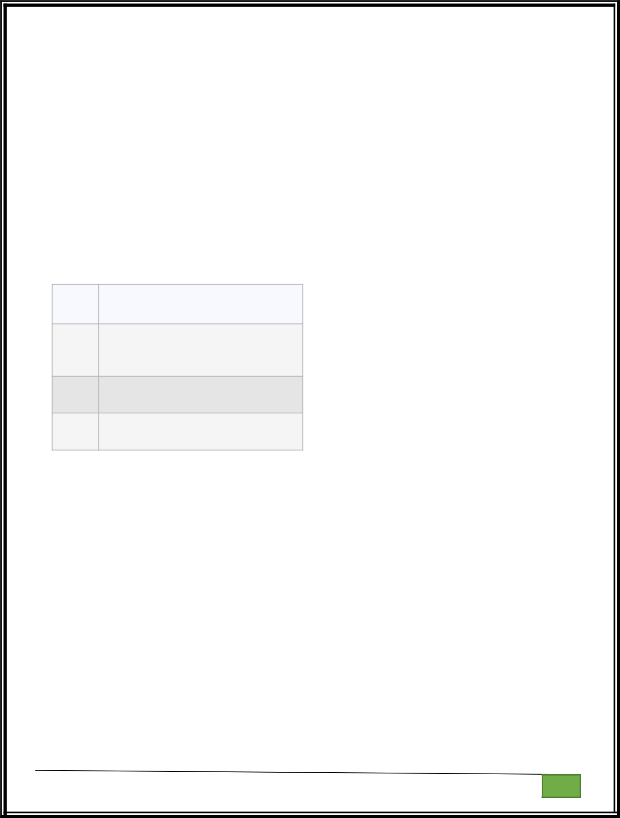
WEEK 11:

1.
Write a Python program that asks the user for their age and prints a message based on the age. Ensure that the program handles cases where the input is not a valid integer.
Input Format: A single line input representing the user's age.

Output Format: Print a message based on the age or an error if the input is invalid.

For example:

Input Result

twent Error: Please enter a valid age.
y

25

You are 25 years old.

-1

Error: Please enter a valid age.

try:

a=input()

if(len(a)==0):

print("Error: Please enter a valid age.")

elif a.isnumeric():

print("You are",a,"years old.")

else:

print("Error: Please enter a valid age.")

except:

print("Error: Please enter a valid age.")

OUTOUT:

Department of Computer Science and Engineering | Rajalakshmi Engineering College

PA.

GE

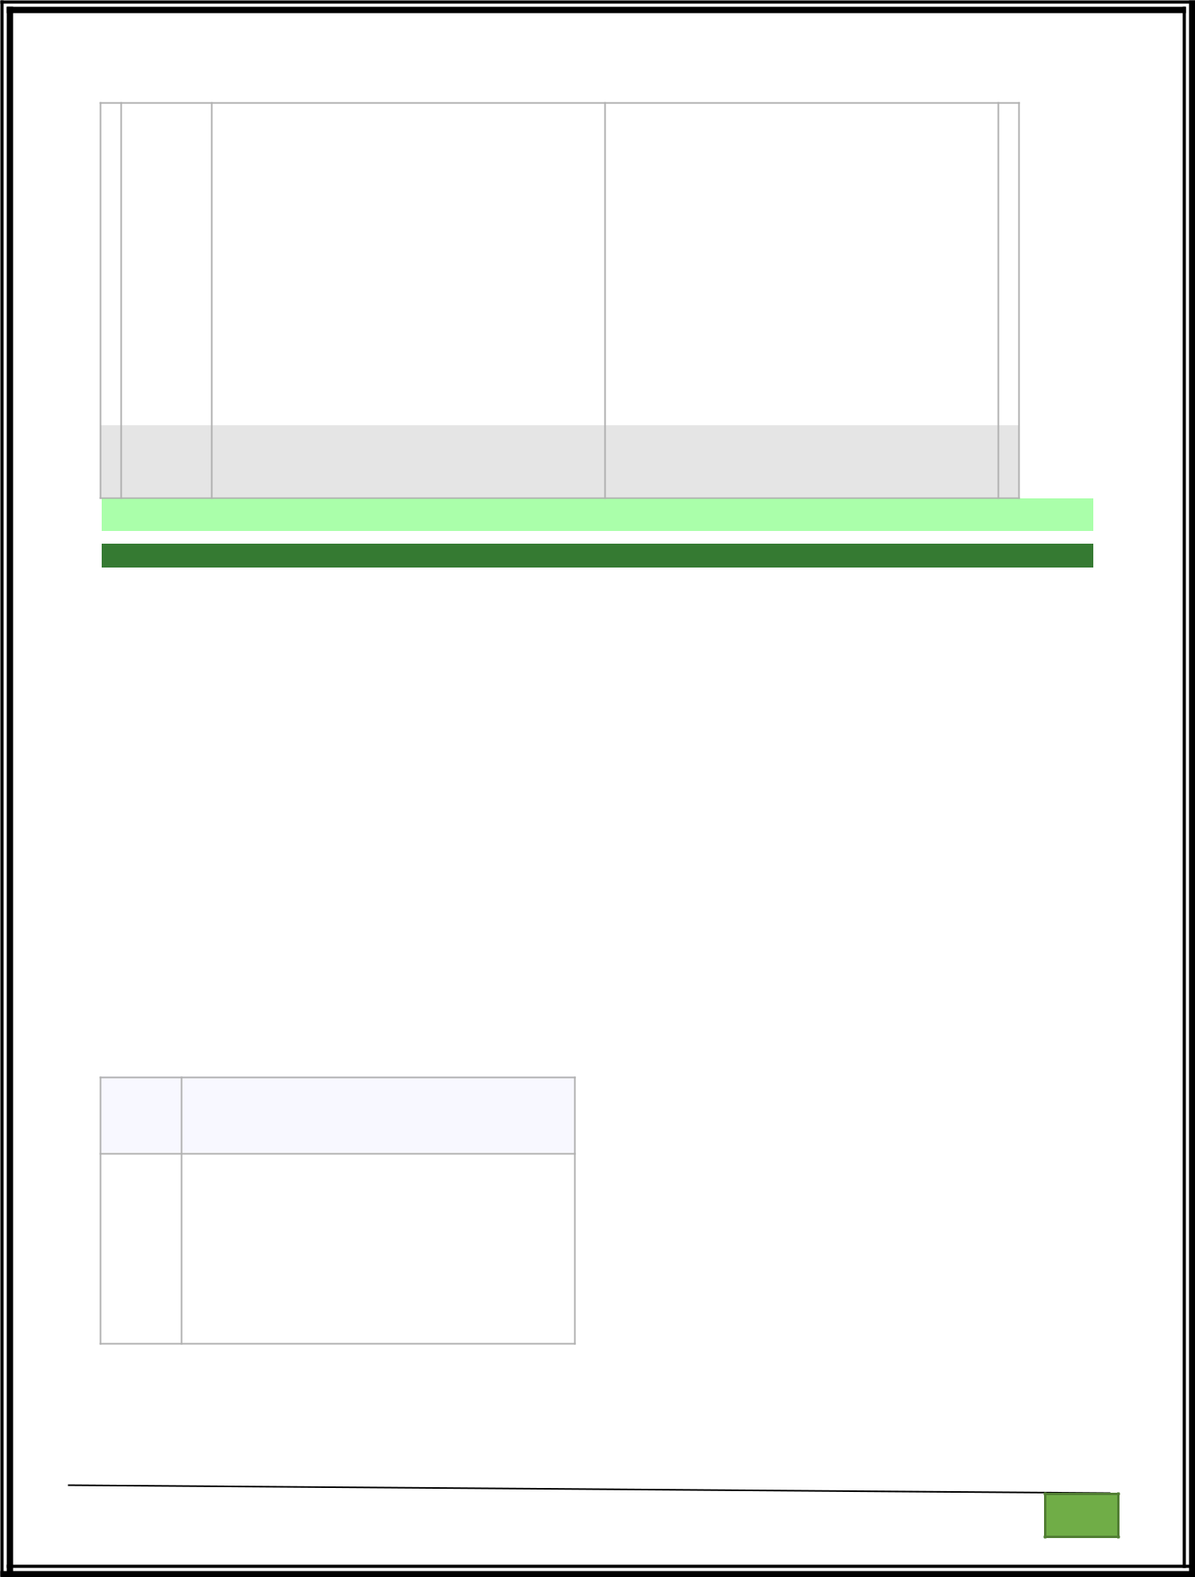 | Input | Expected | Got
 | twenty | Error: Please enter a valid | Error: Please enter a valid age.
 |  | age.
 | 25 | You are 25 years old. | You are 25 years old.
 | -1 | Error: Please enter a valid | Error: Please enter a valid age.
 |  | age.
 | 150 | You are 150 years old. | You are 150 years old.
 |  | Error: Please enter a valid | Error: Please enter a valid age.
 |  | age.

Passed all tests!

Correct

2.
Problem Description:

Write a Python program that asks the user for their age and prints a message based on the age. Ensure that the program handles cases where the input is not a valid integer.

Input Format:

A single line input representing the user's age.

Output Format:

Print a message based on the age or an error if the input is invalid.

For example:

Input Result

25 | You are 25 years old.
rec | Error: Please enter a valid
 | age.
-5 | Error: Please enter a valid
 | age.

try:
a=input()

Department of Computer Science and Engineering | Rajalakshmi Engineering College

PA.

GE


if(len(a)==0):

print("Error: Please enter a valid age.")
elif a.isnumeric():

print("You are",a,"years old.")
else:

print("Error: Please enter a valid age.")
except:
print("Error: Please enter a valid age.")
OUTPUT:

 | Inpu | Expected | Got
 | t | Expected | Got
 | 25 | You are 25 years old. | You are 25 years old.
 | rec | Error: Please enter a valid | Error: Please enter a valid
 |  | age. | age.
 | !@# | Error: Please enter a valid | Error: Please enter a valid
 |  | age. | age.

Passed all tests!

Correct

3.
Problem Description:

Write a Python script that asks the user to enter a number within a specified range (e.g., 1 to 100). Handle exceptions for invalid inputs and out-of-range numbers.
Input Format:

User inputs a number.

Output Format:

Confirm the input or print an error message if it's invalid or out of range.

For example:

Input Result

- Valid input.

- Error: Number out of allowed range

rec | Error: invalid literal for int()

Department of Computer Science and Engineering | Rajalakshmi Engineering College

PA.

GE

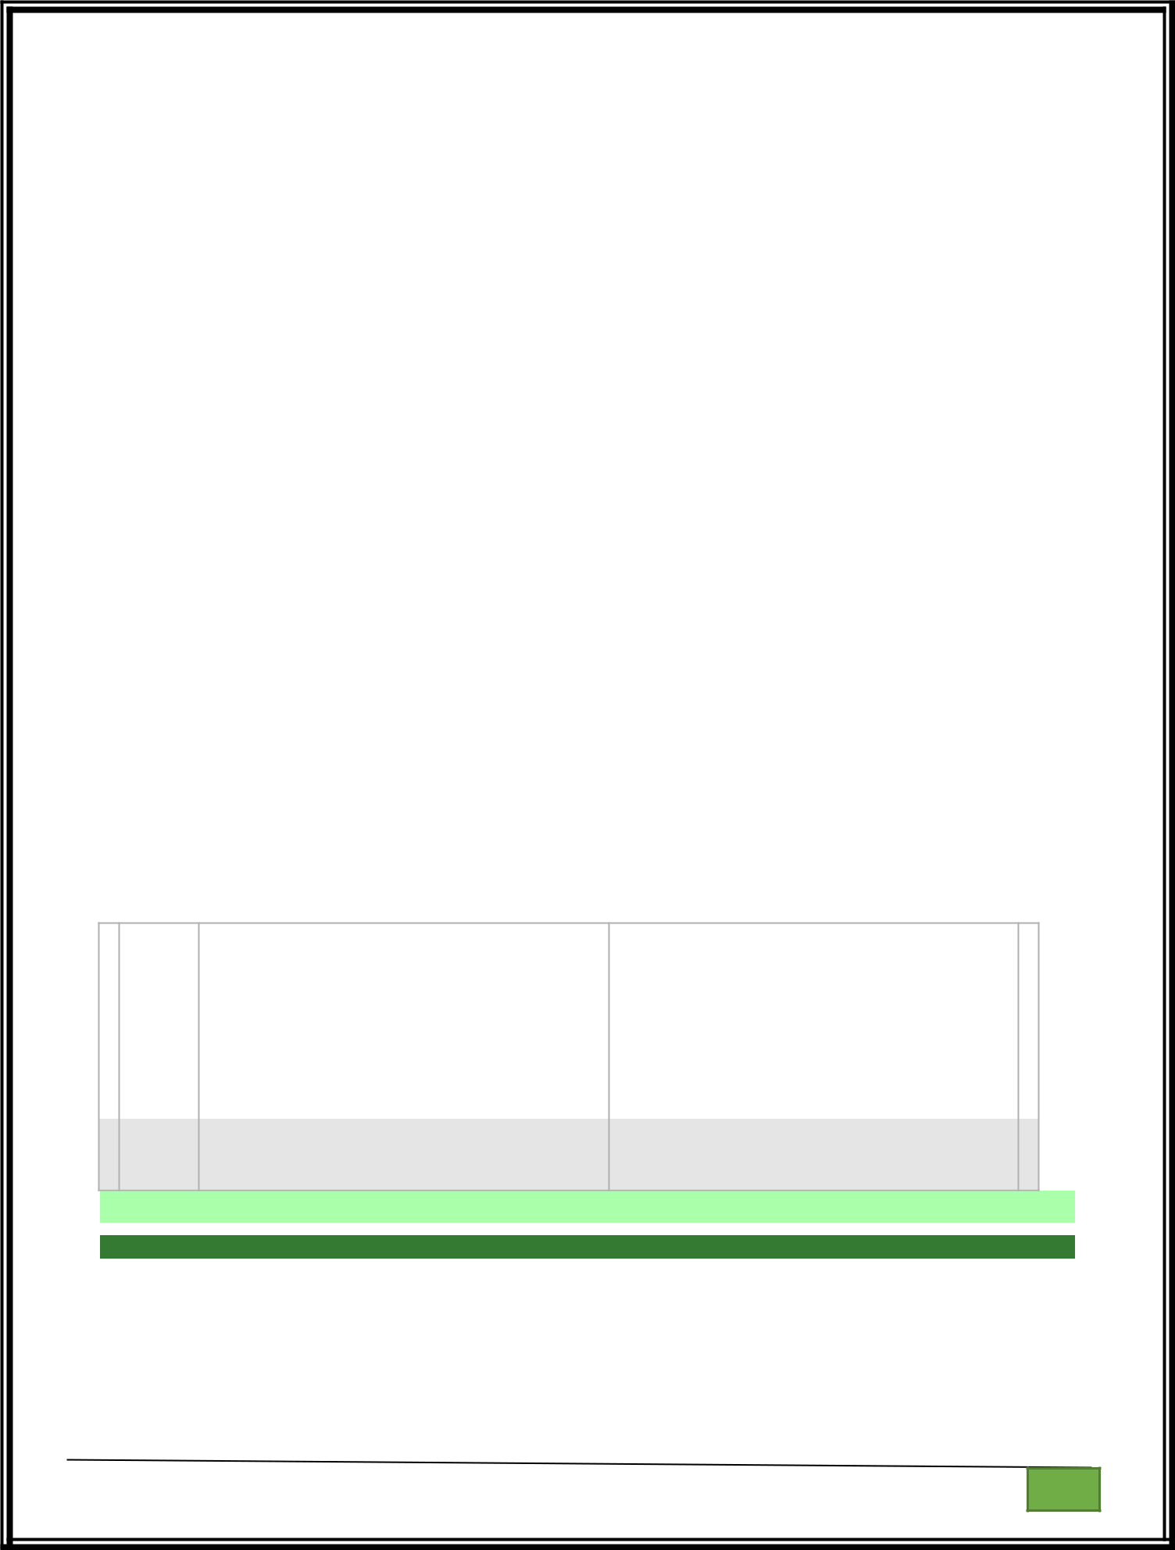

def main():

min_range = 1

max_range = 100

try:

num = int(input())

if num < min_range or num > max_range:

print("Error: Number out of allowed range")

else:

print("Valid input.")

except ValueError:

print("Error: invalid literal for int()")

if __name__ == "__main__":

OUTPUT:

 | Input | Expected | Got
 | 1 | Valid input. | Valid input.
 | 100 | Valid input. | Valid input.
 | 101 | Error: Number out of allowed | Error: Number out of allowed range
 |  | range

Passed all tests!

Marks for this submission: 1.00/1.00.

Correct

4.

Develop a Python program that safely performs division between two numbers provided by the user. Handle exceptions like division by zero and non-numeric inputs.

Department of Computer Science and Engineering | Rajalakshmi Engineering College

PA.

GE

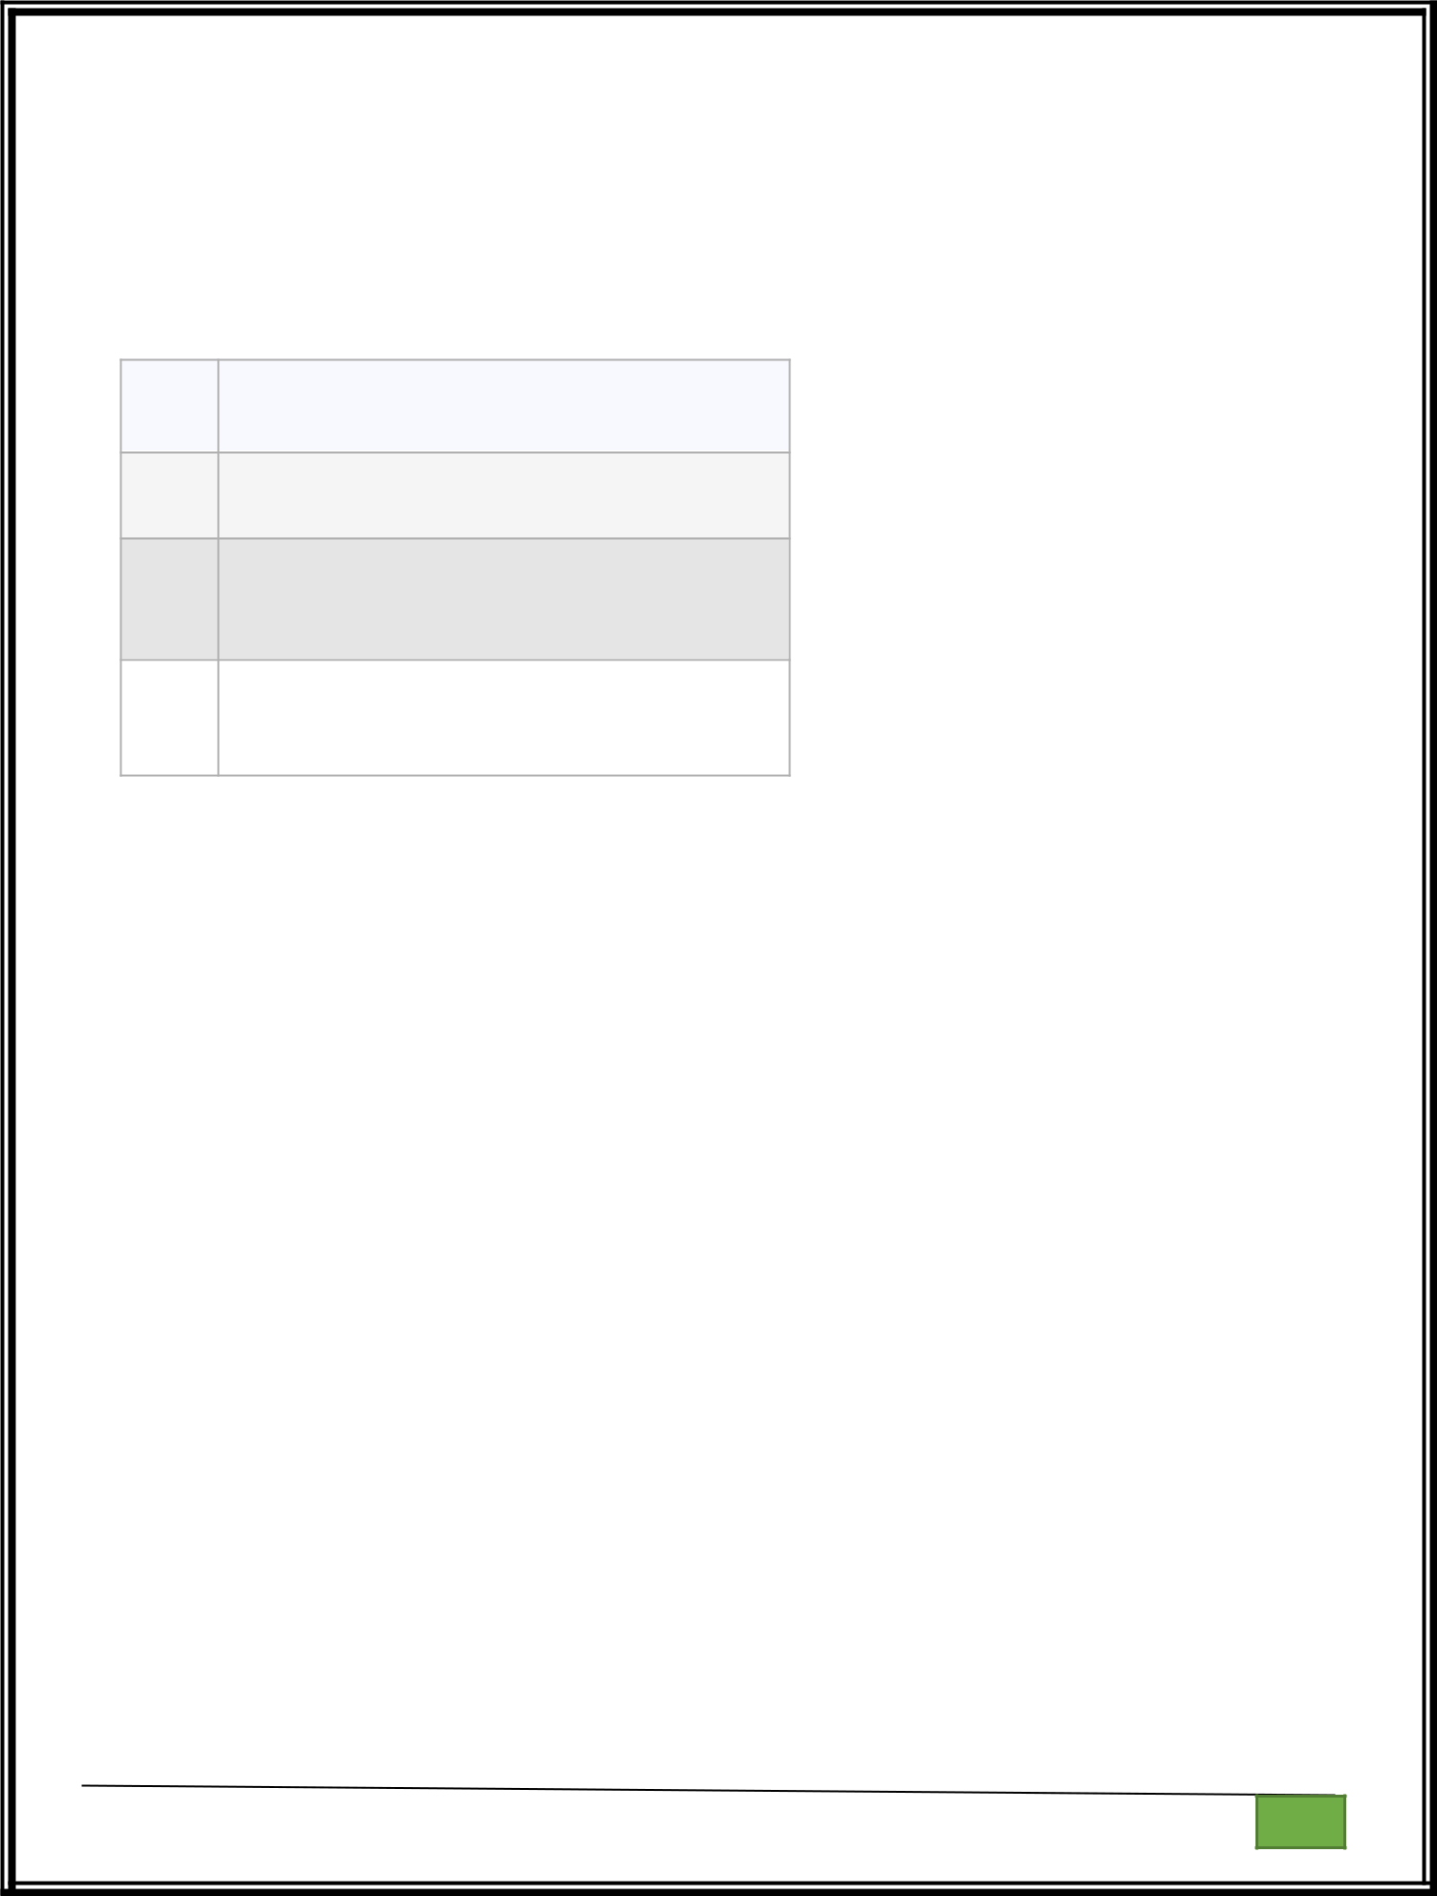
Input Format: Two lines of input, each containing a number.

Output Format: Print the result of the division or an error message if an exception occurs.

For example:

Input Result

- 5.0
2

- Error: Cannot divide or modulo by
0zero.

ten | Error: Non-numeric input provided.
5

def main():

try:

num1 = float(input())

num2 = float(input())

division_result = num1 / num2

modulo_result = num1 % num2

print(division_result)

except ValueError:

print("Error: Non-numeric input provided.")

except ZeroDivisionError:

print("Error: Cannot divide or modulo by zero.")

if __name__ == "__main__":

Department of Computer Science and Engineering | Rajalakshmi Engineering College

PA.

GE

